**Algorithm explanation**

My algorithm consists of two parts, INPUT and OUTPUT. In the first part, I use TRAP instruction to get the character(through a loop) and judge whether it is “Enter”. If not, I use R1 to store it(before storing it, I first set R1 to 10*R1,then let R1 plus that input character). After storing it, the loop continues until “Enter” is input. Otherwise, it means the INPUT part is over and what R1 stores is unsigned integer the user input. Then my algorithm jump into OUTPUT part. In this part,I convert the number stored in R1 to its corresponding hexadecimal number's four parts. For every part, I judge whether it is grater than 9 and use two different methods to convert it to its corresponding ASCII code value and output it.

**Essential parts of your code with sufficient comments**

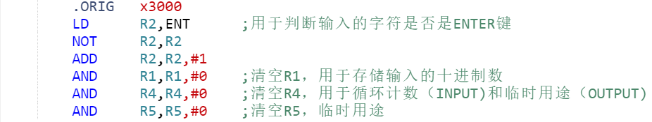

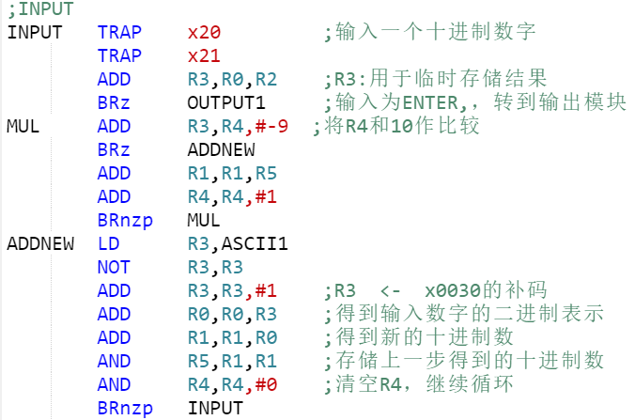（There are four similar OUTPUT sections, each of which is used to output the four corresponding hexadecimal characters）

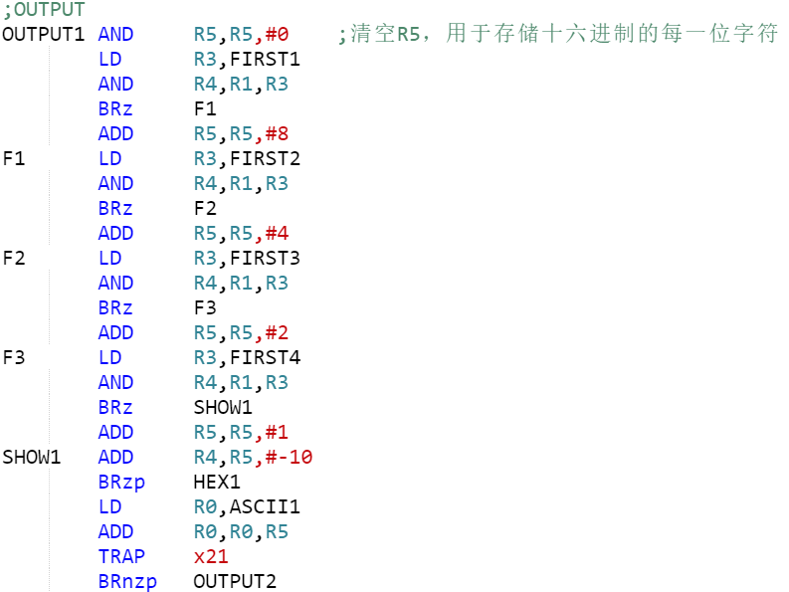

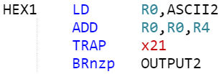

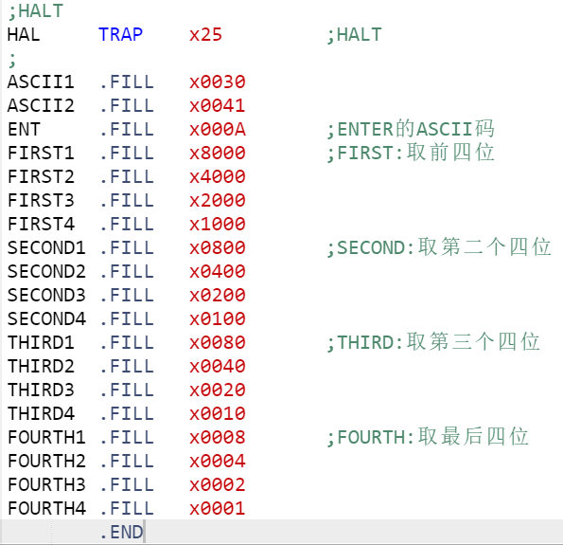

**Questions TA asked you and your answer in Check**

**TA:**What is your approach to this program?

**ME:**First, I use trap instruction to get the character the user inputs one by one and judge if it is “Enter”, if not, I use R1 to store the decimal integer(Clear R1 at first, let R1 equal to 10*R1 and plus the input digit each time). If the user input “Enter”, my algorithm jumps into the OUTPUT section, in which I divide R1’s sixteen binary number into four parts. In every part, I figure out its corresponding decimal integer and convert it into hexadecimal number and output it. The four hexadecimal number is exactly the input decimal integer’s hexadecimal format.